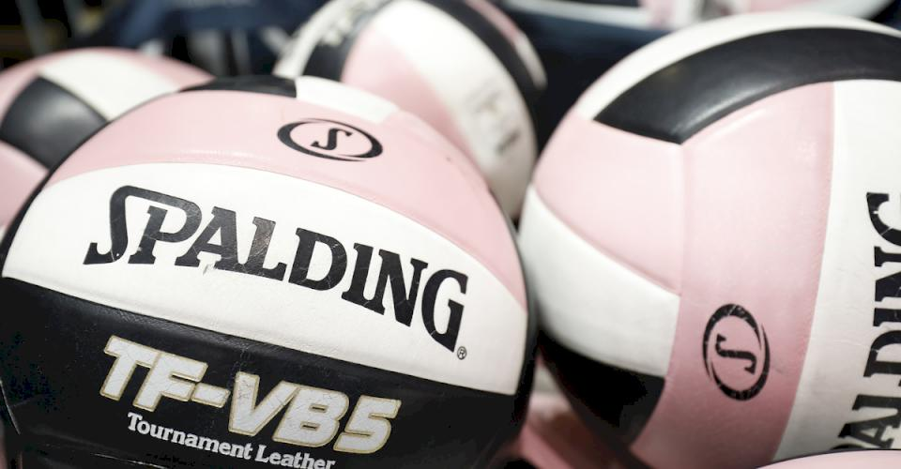

TASJ Fall Volleyball Tournament 2020
This should be considered as providing recommendations from TASJ.

General Guidelines
- People (players, coaches, officials, spectators, etc.) feeling sick or that have been exposed to someone sick, should not attend or participate in competitions or practices.
- The TASJ encourages all participants and spectators to practice social distancing and to wear face mask is mandatory

Pre-Match Procedures
- Attendees for the coin toss is limited to one coach from each team, one captain from each team, first referee and second referee. All six individuals must maintain a social distance of 3 to 6 feet. Face coverings are strongly encouraged to be worn by all pre-match conference attendees.
- Teams are required to bring their own volleyballs to use for warm-ups for away matches. (Volleyballs must be marked to help with identification purposes when traveling with volleyballs.)
- Teams are not allowed to warm-up outside of the court near their opponents while their opponents have the court for the 6-minute portion of the 5-6-6 warm-up protocol, UNLESS there is another court area for them to utilize. It is permissible for teams to share the court for the 5-minute ball handling portion of warm-up as teams will be socially distanced by the net.

During Matches
- Eliminate spectator seating in the first two rows if possible.
- Avoid playing matches simultaneously on side-by-side courts if possible.
- Pre- and postgame handshakes between teams are prohibited. Teams should acknowledge their opponents with a wave, bow, etc. after introductions and/or after the match.
- Teams are not to switch benches between sets. In the event there is a clear and distinct disadvantage, teams may switch sides, observing all social distancing protocols. Officials will determine if a disadvantage is present.
- Bench personnel should observe social distancing as much as possible. Coaches, players and other bench personnel are strongly encouraged to wear face coverings while on the bench.
- All players are allowed to stand near the bench area (not just those in the active rotation) to help with social distancing if needed.
- All players must sanitize their hands before and after warm-ups, at all timeouts, between sets and anytime they leave the playing court. Coaches are strongly encouraged to sanitize their hands as often as possible as well.
- Players and coaches should practice social distancing of 3 to 6 feet when addressing the second referee and during substitutions. Players are encouraged to utilize the substitution zone closer to the attack line rather than nearer the net for social distancing purposes between players and the second referee.
- Attendees for the deciding coin toss are limited to one coach and one captain from each team, first referee and second referee. All individuals must maintain a social distance of 3 to 6 feet. Face coverings are strongly encouraged to be worn by all deciding set coin toss attendees.
- Teams are not to switch benches before a deciding set. In the event there is a clear and distinct disadvantage, teams may switch sides, observing all social distancing protocols. Officials will determine if a disadvantage is present.

Player Equipment & Uniform
- Cloth face coverings are permissible.
- Gloves are permissible.
- Long sleeves are permissible.
- Long pants are permissible.

General Considerations for Volleyball
The following are additional considerations for coaches, student-athletes, officials, parents, and administrators.

Considerations for Coaches
- Communicate your guidelines in a clear manner to Players.
- Team Gatherings at Tournaments – Social distancing from other teams is strongly recommended. This would be a good reminder for parents as well.

Considerations for Athletes
- Consider making each player responsible for their own supplies (water bottle, hand sanitizer, face covering, towel, etc.)
- Players should wear their own appropriate workout clothing (do not share clothing), and individual clothing/towels should be washed and cleaned after every workout immediately upon returning home.
- Hand sanitizer should be plentiful at all contests and practices.
- Athletes should tell coaches immediately when they are not feeling well.
- Cloth face coverings are permissible.

Considerations for Officials
- Take your temperature prior to attending your competition. If temperature is above 100.4 you should notify your Sports committee.
- If you do not feel well and COVID-19 symptoms are present, notify your team and sports committee and assigner immediately and stay home.
- Bring personal hand sanitizer. Wash/sanitize hands upon arrival and frequently throughout your time working the contest(s).
- Do not share equipment.
- Follow social distancing guidelines during pre- and post-match conferences and during contests.
- Consider using electronic whistle.
- Do not shake hands or fist bump other officials, players or coaches.
- Officials may wear face coverings at all times.
- Officials are NOT responsible for monitoring activities on the sidelines, such as social distancing, hand sanitizing, symptoms of illness and other such issues. This monitoring remains with the coaching staff and school personnel.

