Badminton Rules Doubles

Badminton Rules Doubles are pretty much the same as singles. However I get a fair number of questions on doubles rules. Here’s a page to solve all your queries!
Service Boundaries for Badminton Doubles
Serve to the gray area so that the shuttlecock falls INSIDE.
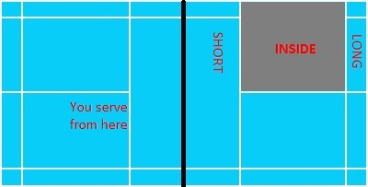
After the receiver retrieve your serve, you can hit the shuttle towards anywhere within the yellow area below.
Badminton Scoring for Doubles – 21 Points
The Badminton Scoring System is commonly known as the 21 Points System or the New Rules.
In doubles, you may get confused about:
- Where should I serve?
- Who’s serving? Me or my partner?
Always remember that a badminton game starts from your right hand side. I’ll give you an example.
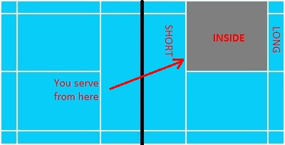
Both pairs have decided that you and your partner starts the game. You and partner decided that you deliver the first serve. The score is 0-0.
Since 0 is an even number, you will serve from the RIGHT side of the
court.
Simple isn’t it? Alright let’s move on with TWO scenarios. Let’s assume you are Player A; Your partner is Player B.
Scenario 1
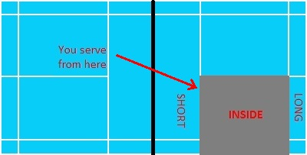
You win the first rally and obtained 1 point. Your opponent’s score remains at 0. Since you have been serving and haven’t lost a rally, you will continue to serve. And since 1 is an ODD number, you will move to the
left hand side of the court to serve.
Scenario 2
You lose the first rally. Your opponent obtained 1 point and your score remains at 0. Since you’ve lost the rally, it’s Service Over for you. Your opponent will serve for the next rally.
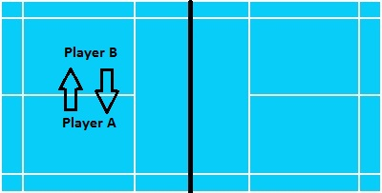

Say you and your partner win the next rally. So your side will serve for the next rally. The score is now 1-1. Since 1 is an ODD number, the serve must be delivered from the left hand side of the court. Remember you had a ‘service over’ during the last rally. So it’s your partner’s turn to serve from the left side (Player B move to the left side and deliver the serve).
Badminton Doubles Rules for Faults
I’ll name some common Badminton Faults in doubles.
Double Hit.
One side has only ONE attempt to retrieve the shuttle. So it’s either you or your partner who is going to hit it. Even if you accidentally touch the shuttle with your racket, and then your partner hits the the shuttle, its still a fault.
Only the Receiver Can Return the Serve.
Let’s say you are the Receiver for a particular rally. So only you can return your opponent’s serve. Your partner cannot return the serve on your behalf.

Service Fault?
Service faults are more likely to be committed when you try to perform the Flick Serve and the ‘perfect serve’ (shuttle passing right above the net).

Rule 4: Toss
- Before commencing play, the opposing sides shall toss a coin and the side winning the toss shall have the option of:
  - serving first,
  - not serving first, or
  - choosing ends
- The side losing the toss shall then have the choice of any alternative remaining. Ends are changed after games one and two. If a third game is necessary, ends are changed during the game after one side has scored 11 points.

Rule 5: Scoring System
- A match consists of best-of-three games to 21 points.
- At 20 all, the side which gains a two-point lead first wins the game.
- At 29 all, the side scoring the 30th point wins that game.
- The side winning a game serves first in the next game.
- Every time there is a serve, there will be a point scored, unless that point is replayed.
- A two-minute break between each game is allowed.
- When the leading score reaches 11 points, players may take a 60-second break if needed.

Rule 6: Doubles Play
- In the traditional scoring system, each side serves except at the start of the game. In the Rally Point Scoring system, a side only has one serve.
- At the beginning of the game and when the score is even, the server serves from the right service court. When it is odd, the server serves from the left court.
- The server must hit the shuttle into the opposite service court. In doubles this extends to the outside rectangular space.
- Once the shuttle is hit after a serve it may be returned into any portion of the other end of the court marked by the outside edges of the boundary lines.
- If the serving side wins a rally, the serving side scores a point and the same server serves again from the alternate service court.
- If the receiving side wins a rally, the receiving side scores a point. The receiving side becomes the new serving side.
- The players do not change their respective service courts until they win a point when their side is serving.
- If players commit an error in the service court, the error is corrected when the mistake is discovered.
- After the serve is played by the receiving team, either partner may make a play on the shuttlecock during consecutive returns.

Rule 7: Faults
- If in serving, the shuttlecock is struck above the server’s waist.
- If at the serve, the shuttlecock falls into the wrong receiving court.
- If the server’s and receiver’s feet are not within the boundaries of their serving court and receiving court, respectively.
- If the partner of the receiver takes the serve.
- If a player touches the net with his/her racquet, person, or clothes.
- If the shuttlecock is struck in return before it has crossed the net to his/her side. (The follow-through may break the plane of the net.)

Rule 8: General Rules
- You should not serve until the opponent is ready, but if he/she attempts to return the serve, he/she is considered ready and play continues.
- If in serving, you miss the shuttlecock, you may serve again providing your racquet did not make any contact during the attempt.
- Birdies that hit the net as they cross during play are good and should be played.
- If, in serving, the shuttle touches the net, it is a “let” provided the service is otherwise good and the birdie is served again.
- Birdies that fall on the line are considered good.

